Biomass Pyrolysis

Hemi-Cellulose composition was fixed at 30% mass fraction.

Vary Cellulose mass fraction from 0 to 70%.

All yields are in mass fractions.

Observations:

* Some graphs show unexpected values when Cellulose mass fraction is equal to 0.
* Most graphs are perfectly linear.
* Quantity of trapped gases is negligible at higher temperatures.

The region where cellulose mass fraction is between 30% and 55% is most commonly observed.

Phenolics: (p-Coumaryl,phenol,sinupaldehyde)

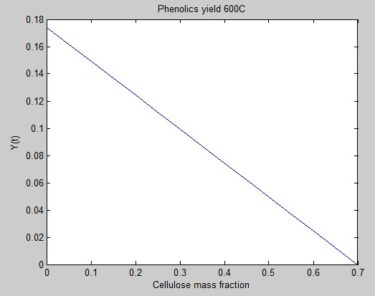

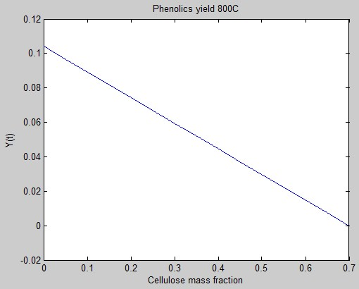

Sugars: (Xylose, Levoglucosan)

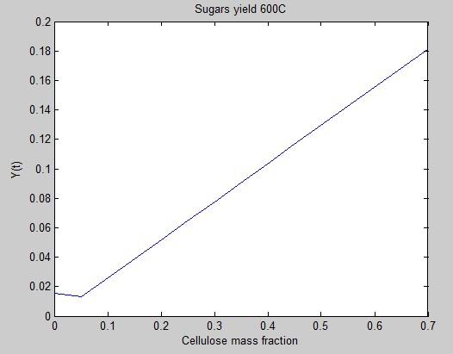

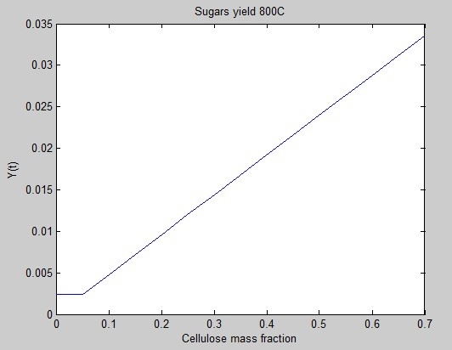

Carbonyls: (Acetaldehyde, Acetone, formic acid, formaldehyde, hydroxyl-acetaldehyde, glyoxal)

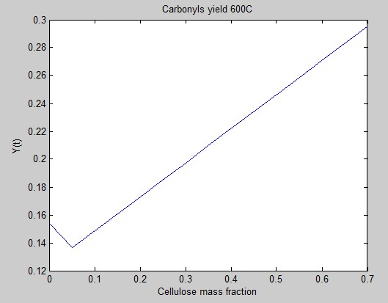

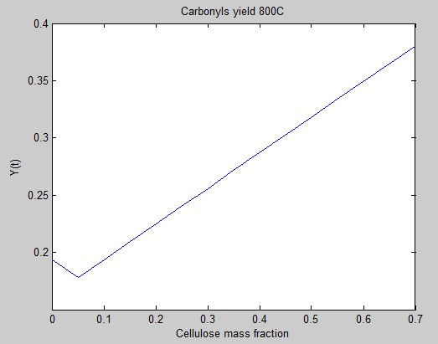

Furans: (Hydroxy methyl furfural)

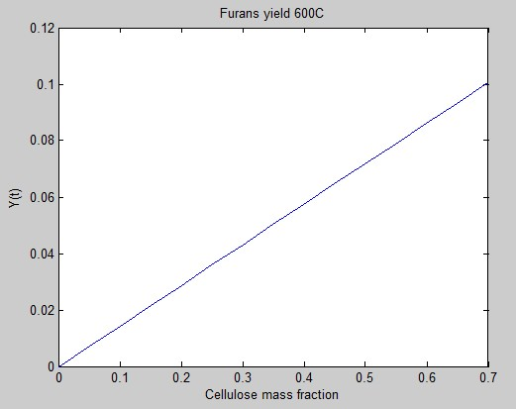

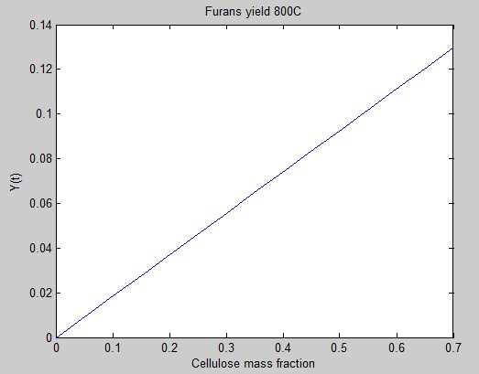

Trapped Gases: (Hydrogen, Methanol, carbon monoxide, methane, ethylene, carbon dioxide)

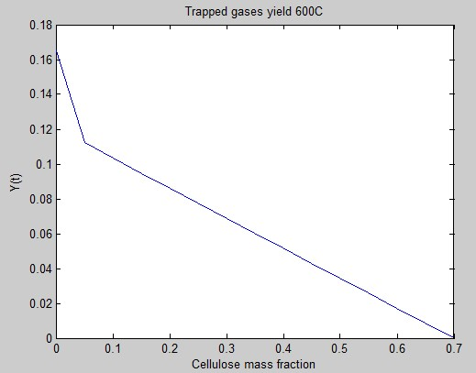

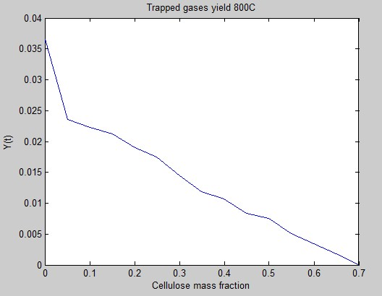

Char:

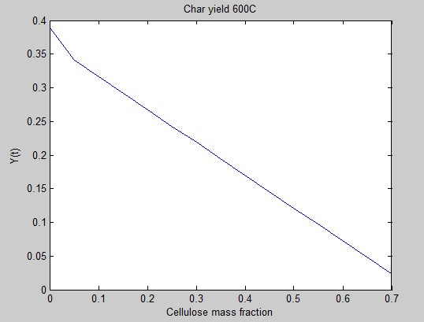

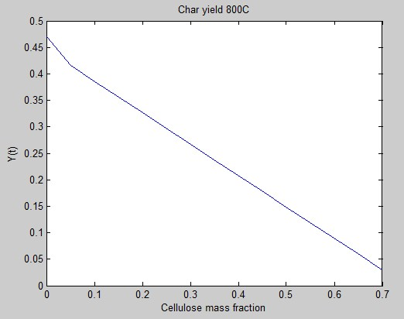

Carbon Monoxide:

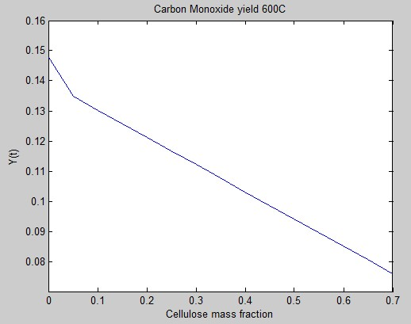

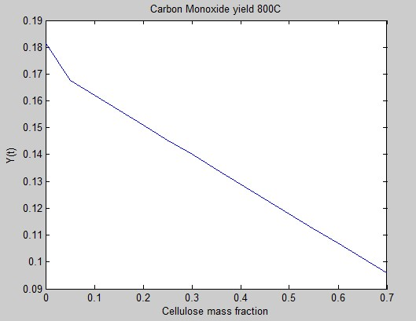

Carbon Dioxide

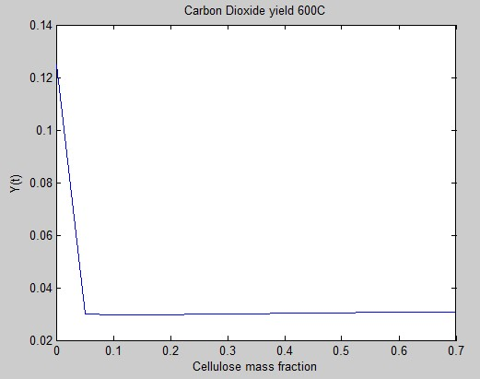

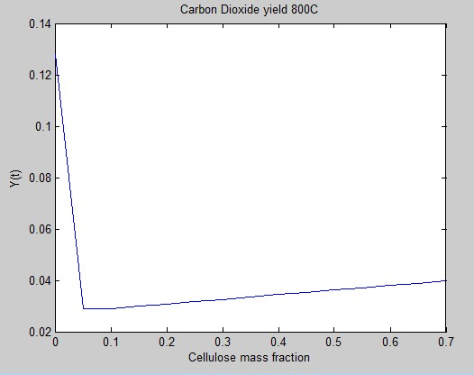

Water Vapor

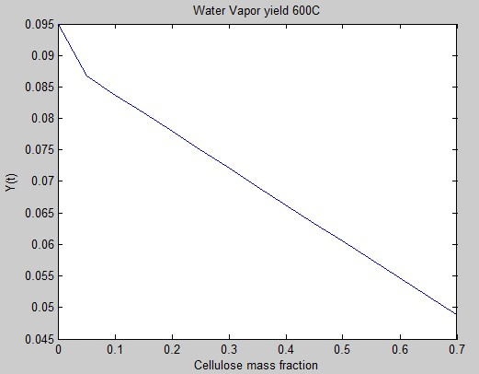

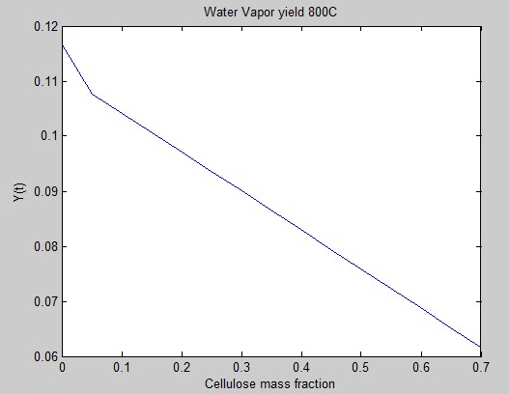

Hydrogen

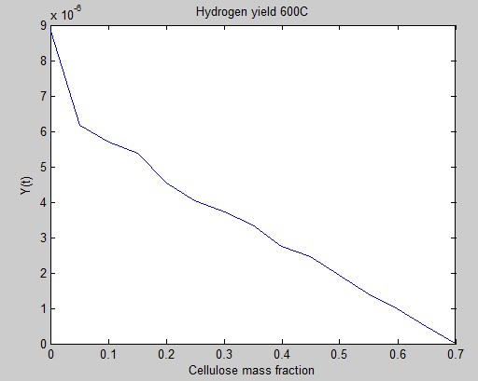

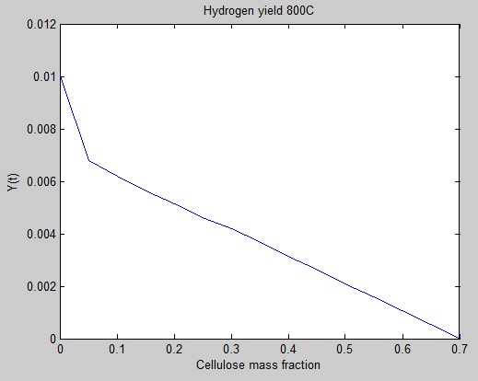

Methane

